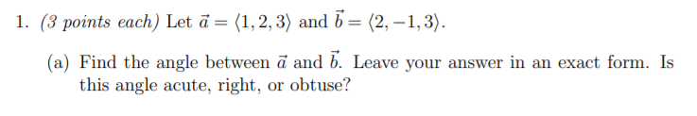
$$\vec{a}=1i+2j+3k, \vec{b}=2i-j+3k$$
Calculating dot product
$$\vec{a }⋅\vec{b }=a_{x}⋅b_{x}+a_{y}⋅b_{y}+a_{z}⋅b_{z}=\left(1×2\right)+\left(2×\left(-1\right)\right)+\left(3×3\right)= 9$$
$$\left|\vec{a}\right|=\sqrt{a_{x}^{2}+a_{y}^{2}+a_{z}^{2}}=\sqrt{1^{2}+2^{2}+3^{2}}=\sqrt{14}$$
$$\left|\vec{b}\right|=\sqrt{b_{x}^{2}+b_{y}^{2}+b_{z}^{2}}=\sqrt{2^{2}+{(-1)}^{2}+3^{2}}=\sqrt{14}$$
Angle between two vectors is given by
$$\cos{α}=\frac{\vec{a }⋅\vec{b }}{\left|\vec{a}\right|\left|\vec{b}\right|}=\frac{9}{14}$$
$$α=\cos^{-1}{\frac{9}{14}}={49.99}^{0} \sim {50}^{0}$$
It is acute angle
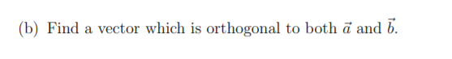
We know that cross product of any two vectors yields a vector which is perpendicular to both vectors
$$\vec{a }×\vec{b } =\left|\begin{matrix}i & j & k \\ 1 & 2 & 3 \\ 2 & -1 & 3\end{matrix}\right|=\left(6+3\right)i-\left(3-6\right)j+\left(-1-4\right)k=9i+3j-5k$$
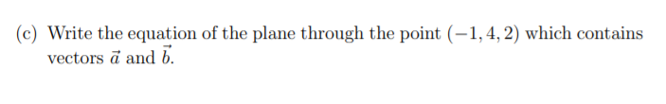
Normal vector to both $\vec{a }×\vec{b }$ is $9i+3j-5k$
Equation of plane containing (-1,4,2) with normal vector $9i+3j-5k$ is
$$9\left(x-\left(-1\right)\right)+3\left(y-4\right)+\left(-5\right)\left(z-2\right)) =0$$
$$→9\left(x+1\right)+3\left(y-4\right)-5\left(z-2\right)=0$$
$$→9x+3y-5z+7=0$$
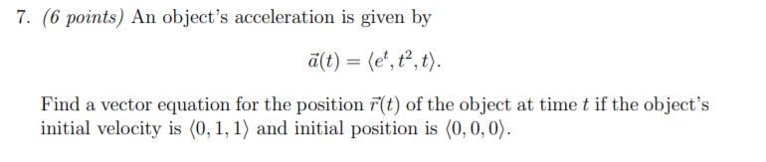
$$a\left(t\right)=(e^{t}, t^{2},t)$$
$$a_{x}=e^{t}$$  $$v_{x}=∫a_{x}dt$$  $$v_{x}=∫e^{t}dt=e^{t}+C$$ | $$a_{y}=t^{2}$$  $$v_{y}=∫a_{y}dt$$  $$v_{y}=∫t^{2}dt=\frac{t^{3}}{3}+C$$ | $$a_{z}=t$$  $$v_{z}=∫a_{z}dt$$  $$v_{z}=∫tdt =\frac{t^{2}}{2}+C$$
We are given that initial velocity as (0,1,1), so
$$v_{x} at t=0→0$$  Putting  $$v_{x}=e^{0}+C=0→1+C=0$$  $$→c= -1$$  $$v_{x}=e^{t}-1$$ | $$v_{y} at t=0→1$$  Putting  $$v_{y}=\frac{0^{3}}{3}+C=1→0+C=1$$  $$→c= 1$$  $$v_{y}=\frac{t^{3}}{3}+1$$ | $$v_{z} at t=0→1$$  Putting  $$v_{z}=\frac{0^{2}}{2}+C=1→0+C=1$$  $$→c= 1$$  $$v_{y}=\frac{t^{2}}{2}+1$$
$$r_{x}=∫v_{x}dt$$  $$r_{x}=∫e^{t}-1 dt$$  $$r_{x}=e^{t}-t+C$$ | $$r_{y}=∫v_{y}dt$$  $$r_{y}=∫\frac{t^{3}}{3}+1dt$$  $$r_{y}=\frac{t^{4}}{12}+t+C$$ | $$r_{z}=∫v_{z}dt$$  $$r_{z}=∫\frac{t^{2}}{2}+1dt$$  $$r_{z}=\frac{t^{3}}{6}+t+C$$
We are given that initial velocity as (0,1,1), so
$$r_{x} at t=0→0$$  Putting  $$r_{x}=e^{0}-0+C=0$$  $$→1-0+C=0$$  $$→C= -1$$  $$r_{x}=e^{t}-t-1$$ | $$r_{y} at t=0→0$$  Putting  $$r_{y}=\frac{0^{4}}{12}+0+C=0$$  $$→0+0+C=0$$  $$→C= 0$$  $$r_{y}=\frac{t^{4}}{12}+t$$ | $$r_{z} at t=0→0$$  Putting  $$r_{z}=\frac{0^{3}}{6}+0+C=0$$  $$→0+0+C=0$$  $$→C= 0$$  $$r_{z}=\frac{t^{3}}{6}+t$$

$$\vec{r}=〈e^{t}-t-1, \frac{t^{4}}{12}+t,\frac{t^{3}}{6}+t〉$$

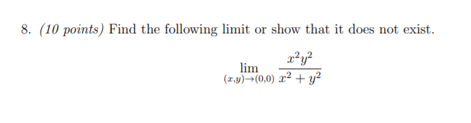
Converting to polar coordinates
$$x=r\cos{θ}, y=r\sin{θ}$$
$$\lim_{r→0}\left(\frac{{\left(r\cos{θ}\right)}^{2}{\left(r\sin{θ}\right)}^{2}}{{\left(r\cos{θ}\right)}^{2}+{\left(r\sin{θ}\right)}^{2}}\right)→ \lim_{r→0}\left(\frac{r^{4}\cos^{2}{θ}\sin^{2}{θ}}{r^{2} \left(\cos^{2}{θ}+\sin^{2}{θ}\right)}\right)→ \lim_{r→0}\left(r^{2}\cos^{2}{θ}\sin^{2}{θ}\right)$$
Simplify
$$\lim_{r→0}\left(r^{2}\cos^{2}{θ}\sin^{2}{θ}\right)=0$$

